AWS

Contents
1. What AWS Gives You 4
2. Regions and Availability Zones 4
3. VPC - Your Private AWS Network 5
4. Subnets 5
5. Public vs Private Subnets 5
6. Security Groups 6
7. EC2 - Generic Compute 6
8. EC2 vs EKS 6
9. ECR - Container Image Registry 7
10. EKS - Managed Kubernetes 7
11. Complete Container Deployment Pipeline 8
12. Application Load Balancer (ALB) 8
13. RDS - Managed Relational Database 9
14. Multi-AZ Database Thinking 9
15. S3 - Object Storage and Data Lake Foundation 9
16. S3 in the KYT Architecture 9
17. MSK - Managed Apache Kafka 10
18. SQS - Durable Work Queues 10
19. SQS vs Kafka 10
20. SNS - Publish/Subscribe Fan-Out 11
21. EventBridge - Rule-Based Event Routing 11
22. IAM - Identity and Access Management 11
23. IAM Policy Mental Model 12
24. IAM User vs IAM Role 12
25. Secrets Manager 12
26. KMS - Cryptographic Key Management 13
27. KMS vs Secrets Manager 13
28. CloudWatch - Observability 13
Logs 13
Metrics 13
Alarms 14
Three Pillars of Observability 14
29. AWS Architecture for Everything Learned So Far 14
30. Example: How a Deposit Could Move Through AWS 15
31. Shared Responsibility 16
32. Least Privilege 16
33. Public Internet vs Internal Services 17
34. High Availability 17
35. Google Cloud Equivalents 17
36. Primary References 18

1. What AWS Gives You
Core mental model: AWS supplies managed infrastructure building blocks. Your job is to know which problem each service solves and how the services fit together.
AWS is a large collection of managed infrastructure building blocks. Instead of buying and operating physical servers, networks, storage arrays, load balancers, database servers, and Kafka machines yourself, you request and manage infrastructure through APIs and managed services.
Need | AWS service
Virtual machine | EC2 (it’s a generic computer)
Kubernetes | EKS
Container image storage | ECR
PostgreSQL / relational DB | RDS
Object storage / data lake | S3
Kafka | MSK
Secret storage | Secrets Manager
Cryptographic keys | KMS

2. Regions and Availability Zones
AWS infrastructure is divided geographically into Regions. Each Region contains multiple Availability Zones (AZs), which are separate infrastructure failure domains inside that Region.
AWS
|
|- Region A
| |- AZ 1
| |- AZ 2
| `- AZ 3
|
`- Region B
|- AZ 1
`- AZ 2
Availability Zones matter because a production system should avoid placing every critical component inside a single failure domain. For example, application Pods may be spread across multiple AZs behind one load balancer.
AZ A AZ B
API Pod API Pod
KYT Pod KYT Pod
\ /
\ /
Load Balancer
Region = geographic deployment area. Availability Zone = failure-isolation boundary inside a Region.

3. VPC - Your Private AWS Network
A VPC (Virtual Private Cloud) is a logically isolated virtual network inside AWS. Within a VPC, you define IP address ranges, subnets, routes, internet connectivity, and security controls.
AWS CLOUD
+----------------------------------------+
| VPC |
| |
| Your organization's virtual network |
| |
+----------------------------------------+
The VPC is the network boundary that contains application infrastructure such as EKS workloads, relational databases, Kafka, and internal services.

4. Subnets
A VPC can span multiple Availability Zones. Individual subnets live inside one AZ. A typical production design uses public subnets for intentional internet-facing infrastructure and private subnets for application and data services.
VPC
+-------------------------------------+
| |
| AZ A AZ B |
| |
| Public Subnet Public Subnet |
| | | |
| `---- Load Balancer ---' |
| |
| Private Subnet Private Subnet|
| | | |
| EKS Pods EKS Pods |
| | | |
| `------ RDS / MSK -----' |
| |
+-------------------------------------+

5. Public vs Private Subnets
A public subnet has a route that can support internet connectivity through an Internet Gateway. Typical public resources include public load balancers and NAT infrastructure. Private subnets normally host Go services, databases, Kafka brokers, and other internal components that should not accept unsolicited internet traffic.
Internet
|
Load Balancer
|
Backend
|
RDS
A financial backend should not expose internal databases or message infrastructure directly to the public internet. Public exposure should be intentional and minimal.

6. Security Groups
A Security Group is a virtual firewall controlling allowed network traffic to supported AWS resources. The architecture should allow only the minimum network paths required by the system.
ALB:
allow Internet -> 443
API workload:
allow ALB -> application port
PostgreSQL:
allow backend -> 5432
Internet
|
443
v
ALB
|
8080
v
Backend
|
5432
v
PostgreSQL
Security-group design follows least exposure: Internet -> load balancer -> backend -> database, rather than Internet -> everything.

7. EC2 - Generic Compute
Amazon EC2 provides virtual machines. An EC2 instance is a configurable virtual server with CPU, memory, storage, and networking. It can run a Go binary directly, Docker containers, or act as compute (worker nodes) underneath Kubernetes.
AWS hardware
|
v
EC2 instance
|
v
Linux
|
v
your process/container
A basic deployment could place a Go process or Docker container directly on EC2, but a serious distributed platform often relies on orchestration rather than manually SSHing into servers and starting processes.

8. EC2 vs EKS
EC2 is generic virtual-machine compute. EKS is AWS managed Kubernetes. EKS workloads still require compute underneath, but Kubernetes schedules and manages containers instead of engineers manually managing each server.
EC2 / managed nodes
|
v
EKS
|
v
Kubernetes
|
v
Pods
EC2 = virtual machines. EKS = managed Kubernetes. They are different layers rather than equivalent products.

9. ECR - Container Image Registry
Amazon ECR (Elastic Container Registry) stores and distributes Docker/OCI container images. A CI system builds a versioned image, pushes it to ECR, and EKS pulls that image when starting Pods.
Developer / CI
|
| docker build
v
kyt-service:abc123
|
| push
v
+----------------+
| ECR |
| |
| api:v31 |
| kyt:v12 |
| observer:v8 |
+-------+--------+
|
| pull
v
EKS
|
v
Pods
ECR also supports image scanning, which can help identify vulnerabilities in image contents.
ECR stores container images; EKS runs Kubernetes workloads based on those images, using EC2 as worker nodes.

10. EKS - Managed Kubernetes
Amazon EKS (Elastic Kubernetes Service) provides managed Kubernetes. The Kubernetes concepts learned remain unchanged: Deployment, ReplicaSet, Pod, Service, HPA, ConfigMap, Secret, readiness, liveness, and rolling updates.
AWS
`- EKS
`- Kubernetes
|- Deployment
|- Pod
|- Service
`- HPA
EKS does not replace Kubernetes knowledge. It removes or reduces the burden of operating Kubernetes infrastructure such as the control plane and, depending on the deployment model, can manage more of the underlying node lifecycle.

11. Complete Container Deployment Pipeline
Developer
|
v
Git commit
|
v
CI
|
|- go test
|
|- docker build
|
v
ECR
|
| image: abc123
v
EKS
|
Deployment
|
Rolling Update
|
v
new Pods
|
readiness
|
v
receive traffic
This connects the Docker and Kubernetes lessons to AWS: source code becomes an immutable image artifact in ECR, then an EKS Deployment rolls out Pods using that exact image.

12. Application Load Balancer (ALB)
An Application Load Balancer is an HTTP/HTTPS entry point that distributes application traffic across healthy targets, potentially across multiple Availability Zones.
USERS
|
v
Application Load Balancer
|
+------------+------------+
v v v
API A API B API C
If one target becomes unhealthy, load-balancer health checks can stop directing normal traffic to that target.
ALB can also route based on HTTP properties such as hosts and paths.
/api/settlements -> Settlement Service
/api/wallets -> Wallet Service
/api/customers -> Customer Service
In EKS, Kubernetes ingress/gateway components can integrate with AWS load-balancing infrastructure.

13. RDS - Managed Relational Database
Amazon RDS is a managed relational database service supporting engines such as PostgreSQL and MySQL. AWS handles significant operational work such as hardware provisioning, backups, patching, and monitoring, while application engineers still design schemas, SQL transactions, indexes, constraints, and connection pooling correctly.
Settlement Pods
|
v
RDS PostgreSQL
A backend team could operate PostgreSQL on EC2 itself, but that also means owning installation, backups, patching, hardware replacement, and more operational work. RDS reduces that burden.

14. Multi-AZ Database Thinking
Financial infrastructure should tolerate common infrastructure failures. Managed high-availability database configurations can replicate or maintain standby capacity across Availability Zones.
AZ A AZ B
Primary DB --------> Standby
Managed service does not mean no database engineering. It means AWS takes responsibility for more of the infrastructure operations.

15. S3 - Object Storage and Data Lake Foundation
Amazon S3 is object storage.
Bucket: stridge-kyt-data
raw/ethereum/...
raw/bitcoin/...
silver/transactions/...
gold/address-features/...
models/model-v17.bin
S3 is not a relational database and should not be treated as a normal local filesystem. Applications store and retrieve objects by bucket and key.

16. S3 in the KYT Architecture
Blockchain
|
v
Kafka
|
v
Spark
|
v
S3
|
|- bronze/
| raw chain data
|
|- silver/
| cleaned transactions
|
`- gold/
KYT features

17. MSK - Managed Apache Kafka
Amazon MSK (Managed Streaming for Apache Kafka) runs Apache Kafka as a managed AWS service. The Kafka concepts remain exactly relevant: topics, partitions, message keys, producers, consumers, consumer groups, offsets, delivery semantics, and replication.
MSK reduces the infrastructure burden of creating and maintaining Kafka broker machines, patching infrastructure, and handling common infrastructure operations. It does not remove the need to understand Kafka architecture.
Blockchain Observer
|
| produce
v
MSK
Kafka Cluster
|
+----+-------+
v v v
KYT Settlement Data Lake
MSK is managed Kafka; it does not eliminate Kafka concepts such as topics, partitions, keys, offsets, and consumer groups.

18. SQS - Durable Work Queues
Amazon SQS is a managed message queue used to decouple distributed components and execute asynchronous jobs.
Producer
|
v
SQS Queue
|
v
Worker
Typical uses include sending webhook jobs, generating reports, processing payouts, or running background tasks.

19. SQS vs Kafka
A useful simplified distinction is that SQS is naturally suited to work queues, while Kafka is suited to durable event streams that may be read independently by multiple consumer groups and replayed.
SQS
Job -> Queue -> Worker
Kafka
Event -> Kafka -> KYT
-> Analytics
-> Data Lake
SQS Standard queues use at-least-once delivery, so duplicate delivery remains possible and idempotency still matters.
Kafka is particularly valuable for high-volume streams, partition ordering, multiple independent consumer groups, offsets, replay, and stream processing. SQS is often simpler for background jobs and one logical processing path.

20. SNS - Publish/Subscribe Fan-Out
Amazon SNS is a publish/subscribe notification service. A publisher can fan out a message to multiple subscriber types or destinations.
SNS Topic
/ | \
/ | \
v v v
SQS Lambda HTTP
Simplified distinction: SQS is primarily queue/work distribution, while SNS is publish/fan-out notification.

21. EventBridge - Rule-Based Event Routing
Amazon EventBridge provides an event bus and routing rules. It receives events from AWS services, applications, or SaaS sources and routes matching events to configured targets.
AWS Service --+
Application ---+--> EventBridge
SaaS ----------+ |
rules / filters
/ \
v v
SQS Lambda
Service | Think of it as | Example
MSK / Kafka | Durable stream of ordered events | Every blockchain transaction is continuously written, and KYT/analytics consume it independently
SQS | Job/work queue | “Process this payout” goes into a queue; one worker picks it up and does the job
SNS | Simple broadcast/pub-sub | “Settlement completed” is published once and sent to email service, webhook service, analytics, etc.
EventBridge | Smart event router | “If event type = payment.failed, send to fraud workflow; if source = Stripe, route elsewhere”

For the roadmap from your lead, MSK/Kafka is the most important messaging service to understand deeply. The others only need recognition-level understanding for now.

22. IAM - Identity and Access Management
IAM answers three fundamental questions: who is making a request, what actions that identity may perform, and which AWS resources those actions may target.
WHO is making this request?
WHAT are they allowed to do?
TO WHICH AWS resources?
For example, a KYT service may need permission to read a trained model from S3, consume from Kafka, read one third-party provider secret, and write logs. It should not automatically be able to delete the production database, modify IAM, or access unrelated wallet-signing secrets.

23. IAM Policy Mental Model
Principal
|
| IAM Policy
v
Action + Resource
KYT workload
ALLOW:
s3:GetObject
RESOURCE:
arn:aws:s3:::kyt-models/*
This represents the principle of least privilege: identities and workloads should receive only the permissions required for their job.
Least privilege is especially important in fintech and blockchain infrastructure because one over-privileged workload can become a path to unrelated sensitive systems.

24. IAM User vs IAM Role
An IAM user is a longer-lived AWS identity, historically often associated with people or application credentials. An IAM role is an identity that can be assumed temporarily by users, workloads, or AWS services.
Modern workloads should prefer temporary role-based credentials over hard-coded permanent AWS access keys.
EKS Pod
|
assumes role
|
v
read S3

25. Secrets Manager
AWS Secrets Manager stores and manages sensitive application values such as database passwords, third-party API keys, OAuth tokens, and provider credentials. It also supports lifecycle features such as secret rotation.
Go service
|
| authenticated via IAM
v
Secrets Manager
|
v
Provider API key
Secrets should not be committed to Git repositories or embedded into Docker images.

26. KMS - Cryptographic Key Management
AWS KMS (Key Management Service) creates and controls cryptographic keys used for encryption and cryptographic operations. Keys are protected by AWS cryptographic infrastructure and HSM-backed systems.
Application / AWS service
|
v
KMS
|
v
cryptographic operation

27. KMS vs Secrets Manager
Secrets Manager | KMS
Stores application secrets such as passwords, API keys, tokens, and DB credentials | Manages cryptographic keys and cryptographic operations such as encryption/decryption and key management
Can use KMS underneath for encryption | Protects/controls encryption keys

Secrets Manager
|
| protected by
v
KMS
IAM answers WHO can access WHAT. Secrets Manager answers WHERE application secrets are stored. KMS answers HOW cryptographic keys and cryptographic operations are managed.

28. CloudWatch - Observability
Amazon CloudWatch provides monitoring and observability through logs, metrics, alarms, and dashboards. It helps engineers understand application and infrastructure behavior when something fails or degrades.

Logs
INFO settlement started
ERROR provider request failed
INFO settlement completed
Pod stdout/stderr
|
v
logging system
|
v
CloudWatch Logs

Metrics
Metrics are numerical time-series measurements rather than individual log messages. Useful examples include HTTP request count, p95 latency, 5xx rate, CPU, memory, Kafka consumer lag, pending settlements, settlement failure rate, and KYT scoring latency.

Alarms
CloudWatch Alarms can evaluate metrics against thresholds and trigger notifications or automation. A professional backend should not depend on users complaining before engineers discover an outage.
settlement failure rate > 5%
|
| for configured duration
v
ALARM
|
page / notify / automate

Three Pillars of Observability
LOGS
What happened?
METRICS
How much / how often / how bad?
TRACES
Where did one request travel?
API
|
v
Settlement
|
v
KYT
|
v
Provider
Distributed tracing follows a request through a chain of services. You do not need to learn every CloudWatch observability feature today; understand why logs, metrics, traces, and alarms exist.
CloudWatch is observability infrastructure. It is not the source of truth for financial business state.

29. AWS Architecture for Everything Learned So Far
The following is an educational Stridge-style architecture, not a claim about Stridge's private deployment.
This diagram connects the backend week: Kubernetes/EKS runs application workloads, RDS stores transactional state, MSK carries event streams, S3 stores large KYT datasets, Secrets Manager/KMS protect sensitive values and keys, IAM controls access, and CloudWatch provides observability.
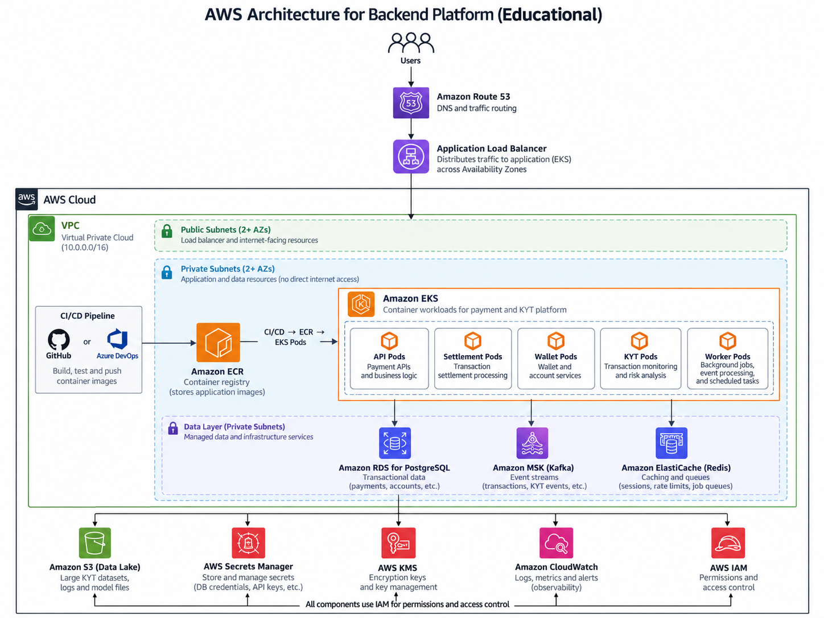

30. Example: How a Deposit Could Move Through AWS
1. Observer: An observer running in an EKS Pod detects a blockchain deposit.
2. Event: The observer publishes DepositConfirmed to Amazon MSK.
3. KYT: KYT Pods consume the Kafka event. They may read a model from S3 and retrieve a provider API key from Secrets Manager. IAM determines whether the Pods may access those resources.
4. Result: The KYT service writes the risk result to RDS and publishes WalletRiskAssessed to MSK.
5. Settlement: The settlement service consumes the event and processes the settlement, using the Transactional Outbox pattern in RDS for reliable event publication.
6. Logs: Every service sends operational telemetry toward CloudWatch.
7. Scaling: When traffic or processing backlog increases, Kubernetes HPA changes KYT Pod replica counts inside EKS.
This flow connects Days 1-7 into one coherent backend system.
The flow:

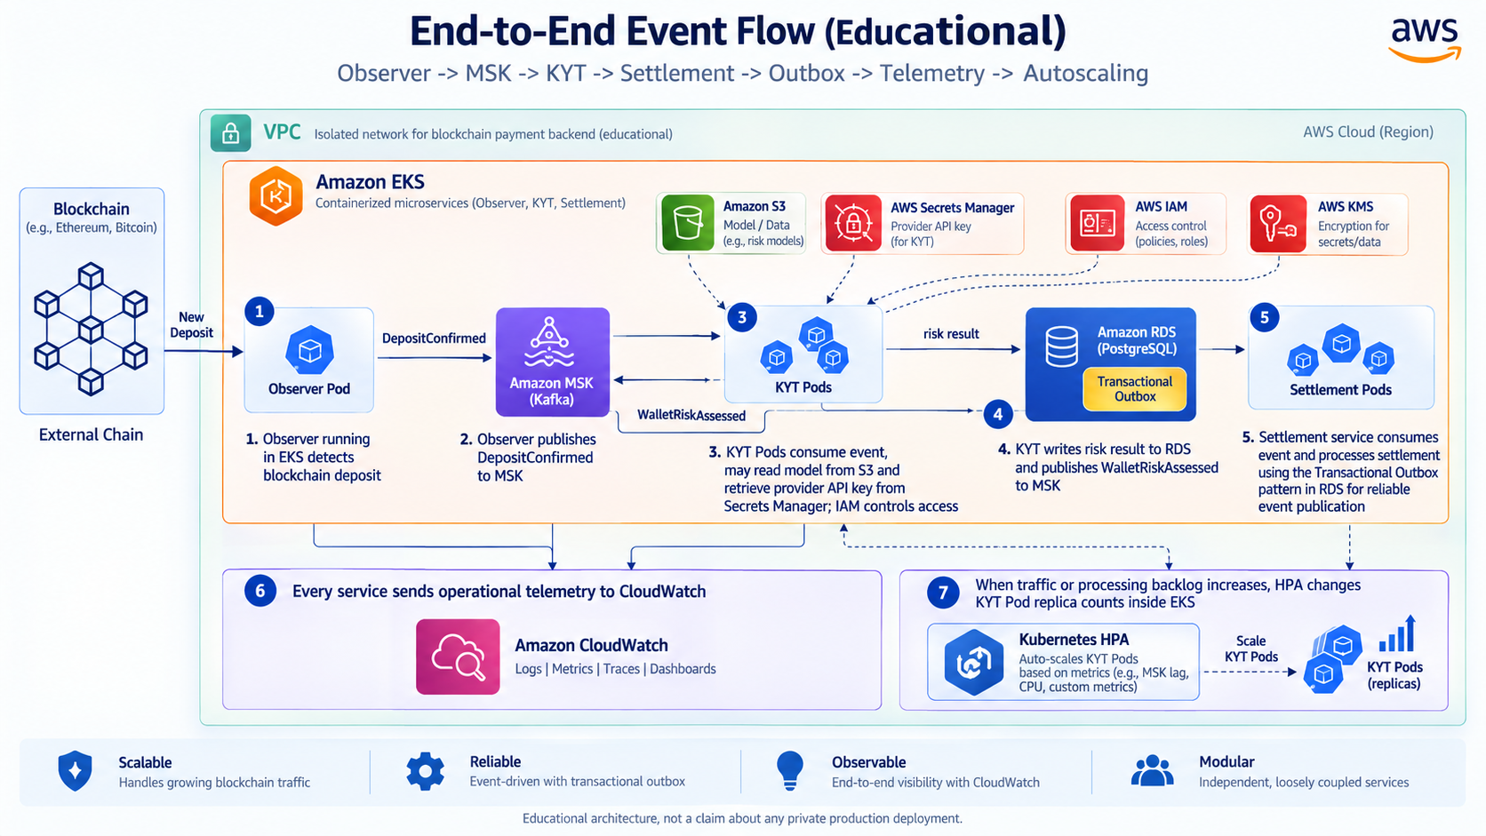
31. Shared Responsibility
A useful AWS security model is: AWS is responsible for security OF the cloud, while customers remain responsible for significant security IN the cloud.
AWS maintains physical infrastructure and managed-service platform components. Your team is still responsible for issues such as bad IAM policies, publicly exposed databases, leaked API keys, vulnerable Go applications, incorrect Security Groups, broken authorization, and poor sensitive-data decisions.
AWS does not rescue an insecure application architecture.

32. Least Privilege
BAD:
KYT_SERVICE_ROLE
Action: *
Resource: *
This means the KYT service could potentially perform unrelated, dangerous actions across the AWS environment.
BETTER:
KYT_SERVICE_ROLE
can:
read specific S3 model bucket
read specific provider secret
consume required Kafka resources
write required logs
cannot:
delete RDS
modify IAM
access unrelated wallet secrets
Least privilege should be applied to both network access and IAM permissions.

33. Public Internet vs Internal Services
Not every service should be internet-accessible. An external API entry point may be public, while KYT, settlement, PostgreSQL, and Kafka remain private.
PUBLIC
ALB
|
v
PRIVATE
API
Settlement
KYT
RDS
MSK
Only the required entry point should be public. Internal service exposure should be minimized.

34. High Availability
Avoid unnecessary single points of failure. If every application Pod, database, and Kafka component exists only in one Availability Zone, an AZ-level failure can take the whole company offline.
Load Balancer
/ \
AZ A AZ B
API Pods API Pods
KYT Pods KYT Pods
\ /
managed DB/Kafka
with HA configuration
You do not need to design active-active multi-region infrastructure yet. The essential concept is spreading critical capacity across failure domains where appropriate.

35. Google Cloud Equivalents
here is no need to repeat the entire architecture lesson. Learn the product-name mapping; the underlying architecture stays the same.
AWS | Google Cloud | Purpose
EC2 | Compute Engine | Virtual machines
EKS | GKE | Kubernetes
ECR | Artifact Registry | Container images
RDS | Cloud SQL | Managed SQL
S3 | Cloud Storage | Object/data-lake storage
MSK | Managed Service for Apache Kafka | Kafka
SQS / SNS | Pub/Sub | Messaging/pub-sub
ALB | Cloud Load Balancing | Load balancing
IAM | Cloud IAM | Identity/permissions
KMS | Cloud KMS | Cryptographic keys
Secrets Manager | Secret Manager | Secrets
CloudWatch | Cloud Monitoring / Logging | Observability

The service names change between AWS and Google Cloud; the architecture does not.

36. Primary References
- AWS VPC User Guide
- AWS VPC Subnets
- Amazon EC2 Concepts
- Amazon ECR User Guide
- Amazon EKS User Guide
- Application Load Balancer
- Amazon RDS Overview
- Amazon S3 Developer Guide
- Amazon MSK Developer Guide
- Amazon SQS Developer Guide
- Amazon SNS API Overview
- Amazon EventBridge Concepts
- AWS IAM User Guide
- AWS Secrets Manager User Guide
- AWS KMS Developer Guide
- Amazon CloudWatch User Guide

